COMP 0560: Artificial Intelligence I
Final Exam
Summer 1999

Name_____________________________________

There is a total of 165 points. Your grade on this exam will be determined as follows:

Your_Grade = Exam_Score/165

Chapter 1: Introduction to AI

- [5pts] In the textbook, the authors discuss 4 approaches for (in defining) Artificial Intelligence. List and briefly describe them?

- [10pts] List four candidates that were tried as names for what is now called Artificial Intelligence.

COMP 0560: Artificial Intelligence I
Final Exam
Summer 1999

Chapter 2: Agents

- [5pts] Agent = __________ + ___________.

- [10pts] Explain the difference between a performance measure and a utility function?

COMP 0560: Artificial Intelligence I
Final Exam
Summer 1999

Chapter 3: Uniformed Search

- [15pts] A new uniformed search method has been discovered! It is called iterative deepening/uniform-cost search. Some may know of this search as IDA* where f(n) = g(n) + h(n) (where h(n) = 0 for all n). Using the Figure below, what order will the nodes be expanded using (a) iterative deepening, (b) uniform-cost search, and (c) iterative deepening/uniform-cost search.

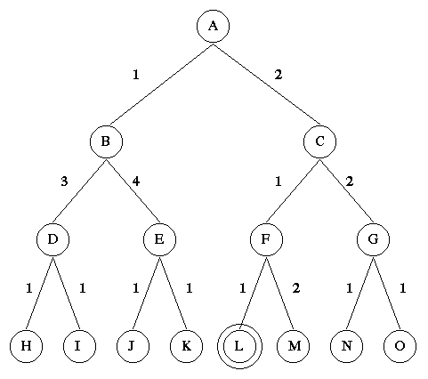

COMP 0560: Artificial Intelligence I
Final Exam
Summer 1999

Chapter 4: Informed Search

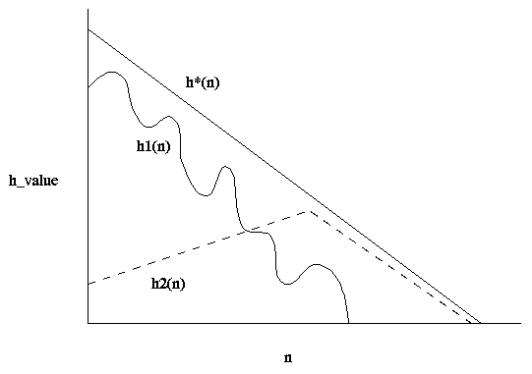

- [20pts] Given the figure above. Answer the following questions (Let h*(n) represent the actual cost of going from state n to the goal).

- Which heuristics are admissible?

- Which heuristics are monotonic?

- Which heuristic is more informed?

- Is it possible to construct an evaluation function f(n) that uses both of these heuristics? If so, provide f(n).

COMP 0560: Artificial Intelligence I
Final Exam
Summer 1999

Chapter 5: Game Playing

- [15pts] Using the two-ply game tree below.

- [10pts] Show what MAX’s best first move would be using Alpha-Beta pruning. Make sure that you identify which edges are to alpha/beta pruned.

- [5pts] What is the horizon problem?

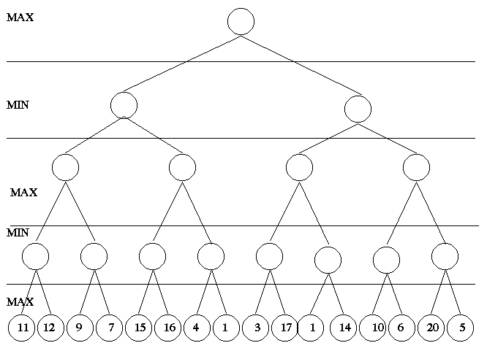

COMP 0560: Artificial Intelligence I
Final Exam
Summer 1999

Chapters 6,7,9: Propositional & First Order Logic

- [10pts] Convert the following sentences into propositional logic and use resolution refutation to prove: you are either too warm or get soaked.

If it is raining then put on your raincoat. If it is not raining then you are too warm. If it is raining and you don’t put on your raincoat then you will get soaked! You didn’t put on your raincoat!!!
COMP 0560: Artificial Intelligence I
Final Exam
Summer 1999

- [5pts] In first order logic we can quantify over ________________. In higher order logics we can quantify over __________________.

- [5pts] What is the difference between linear input and ancestry filtering?

- [5pts] What is a most general unifier?

- [10pts] Convert the following sentences into first order logic and use resolution refutation along with Green’s theorem to answer the question: “Who is an animal?”.

Petey is a rock. Pokey is a horse. All horses are animals.

- [10pts] Given a world (a universe) in which there are 4 propositions A, B, C, D, how many models exist for the following sentence.

A∨ B ⇒ C∨ D

COMP 0560: Artificial Intelligence I
Final Exam
Summer 1999
.

Chapter 18: Learning from Observations

- [5pts] List the 4 conceptual components of a learning agent.

[10pts] Given the following training set compute the entropy and the gain for attributes A and B. Of the two attributes which should be the root of the induction tree?

A | B | Desired Output
+ | + | +
- | + | -
+ | - | -
- | + | +

COMP 0560: Artificial Intelligence I
Final Exam
Summer 1999

Introduction to Evolutionary & Swarm Intelligence

- [10pts] What is difference between Evolutionary Programming, Evolution Strategies and Genetic Algorithms?

- [5pts] Of the reproduction methods discussed in class (generational, steady-state, (μ+λ), (μ,λ)) which most closely resembles beam search?

- [10pts] List the six principles of swarm intelligence.

Extra Credit

[5pts] In the Fundamental Theorem of Genetic Algorithms, single-point crossover is used. Calculate the probability of disruption of a schema, H, if two-point crossover were used instead.

[5pts] In class we discussed 1-point crossover, 2-point crossover, and uniform crossover. If one wanted to crossover two parent strings, xxxxxxx and yyyyyyy, using 3-point crossover, what would the two offspring look like?

COMP 0560: Artificial Intelligence I
Final Exam
Summer 1999

COMP 0560: Artificial Intelligence I
Final Exam
Summer 1999

COMP 0560: Artificial Intelligence I
Final Exam
Summer 1999

